**• WHAT IS SDLC?**

**−SDLC ( Software Development Life Cycle ) is essentially a series of steps, or phase , that provide a model for the development and lifecycle management of an application or piece of software.**

**−SDLC is a structure imposed on the development of a software product that defines the process for planning, implementation and support.**

**• WHAT IS SOFTWARE TESTING?**

**−Software testing is a process used to identify correctness, completeness and quality of developed computer software.**

**−the process consisting of all life cycle activities both static and dynamic, concerned with planning, preparation and evaluation of software products and related work products to determine that they satisfy specified requirements to demonstrate that they are fit for purpose and to detect defects.**

**• WHAT IS AGILE METHODOLOGY?**

**−Agile SDLC model is a combination of iterative and incremental process model with focus on process adaptability and customer satisfaction by rapid delivery of working software product.**

**−agile model believes that every project needs to be handled differently and the existing methods need to be tailored to best suit the project requirements.**

**• WHAT IS SRS?**

**−A software requirements specification (SRS) is a complete description of the behavior of the system to be developed.**

**−it includes a set of use cases that describe all of the interaction that the users will have with the software.**

**• WHAT IS OOPS?**

**−identifying objects and assigning responsibilities to these objects.**

**−object communicate to other objects by sending messages.**

**• WRITE BASIC CONCEPTS OF OOPS**

**−Object**

**−CLASS**

**−Encapsulation**

**−Inheritance**

**−Polymorphism**

**Overriding**

**Overloading**

**−Abstraction**

**• WHAT IS OBJECT?**

**−An object represents an individual, identifiable item, unit, or entity, either real or abstract with a well defined role in the problem domain.**

**−that is both data and function that operate on data are bundled as a unit called object.**

**• WHAT IS CLASS?**

**−A class represents an abstraction of the object and abstracts the properties and behavior of the object.**

**−when you define a class , you definea blueprint for an object.**

**−class can be considered as the blueprint or definition or a template for an object and describes the properties and behavior of that object, but without any actual existence.**

**• WHAT IS ENCAPSULATION?**

**−Encapsulation is the practice of including in an object everything it needs hidden from other objects.**

**−the internal state is usually not accessible by other objects.**

**• WHAT IS INHERITANCE?**

**−Inheritance means that one class inherits the characteristics of another class. This is also called a is a relationship.**

**−this is a very important concept of object-oriented programming since this feature helps to reduce the code size.**

**• WHAT IS POLYMORPHISM?**

**−Polymorphism means “having many forms”**

**−it allows different objects to respond to the same message in different ways, the response specific to the type of the object.**

**• WRITE SDLC PHASE WITH BASIC INTRODUCTION**

1. **Requirement gathering**

**-establish customer needs**

**-the process of identifying your projects exact requirement from start to finish.**

**2>Analysis**

**-the analysis phase defines the requirements of the system**

**Independent of how these requirements will be accomplished .**

**3>Design**

**-the design team can now expand upon the information**

**established in the requirement document.**

**4>Implementation (developer)**

**-in the implementation phase, the team builds the components**

**either from scratch or by composition.**

**5>Testing**

**-the testing phase is a separate phase which is performed by a**

**different team after the implementation.**

**6>Maintenance**

**-software maintenance is one of the activities in software**

**engineering and is the process of enhancing and optimizing**

**deployed software as well fixing defects.**

**• EXPLAIN PHASE OF THE WATERFALL MODEL**

**−The software development as a step by step waterfall between the**

**various development.**

**-Requirements**

**-the process of identifying your projects exact requirement from start to finish.**

**-Analysis**

**-the analysis phase defines the requirements of the system**

**-Design**

**-the design team can now expand upon the information**

**-Implementation**

**-in the implementation phase, the team builds the components**

**either from scratch or by composition**

**−Testing**

**-the testing phase is a separate phase which is performed by a**

**different team after the implementation**

**−Maintenance**

**-software maintenance is one of the activities in software**

**engineering and is the process of enhancing and optimizing**

**deployed software as well fixing defects**

**•WRITE PHASE OF SRIRAL MODEL**

**−The spiral model has four phase**

**−Planning**

**−Design**

**−Construct**

**−Evaluation**

**•WRITE AGILE MANIFESTO PRINCIPLES**

**−Individuals and interaction**

**−Working software**

**−Customer collaboration**

**−Responding to change**

**• EXPLAIN WORKING METHODOLOGY OF AGILE MODEL AND ALSO**

**WRITE PROS AND CONS.**

**−Agile methods focus on the ability of a team to be flexible, encouraging team members to identify uncertainties in their projects and adapt to challenges.**

**−The agile methodology is a project management approach that involves breaking the project into phase and emphasizes continuous collaboration and improvement.**

**−Pros**

**. is a very realistic approach to software**

**.promotes teamwork and cross training**

**.functionality can be development rapidly and demonostrated**

**.resource requirements are minimum**

**.suitable for fixed or changing requirements**

**.delivers early partial working solutions**

**.good model for environments that change steadily**

**.minimal rules, documentation easily employed**

**.little or no planning required**

**.easy to manage**

**.gives flexibility to developers**

**−Cons**

**.not suitable for handling complex dependencies**

**.more risk of sustainability, maintainability and extensibility**

**.an overall plan, an agile leader and agile pm practice is a must without which it will not work**

**.strict delivery management dictates the scope, functionality to be delivered and adjustments to meet the deadlines**

**.depend heavily on customer interaction so if customer is not clear, team can be driven in the wrong direction.**

**.there is high individual dependency, since there is minimum documentation generated.**

**.transfer of technology to new team members may be quite challenging due to lack of documentation.**

**DRAW USECASE ONLINE BOOK SHOPPING**

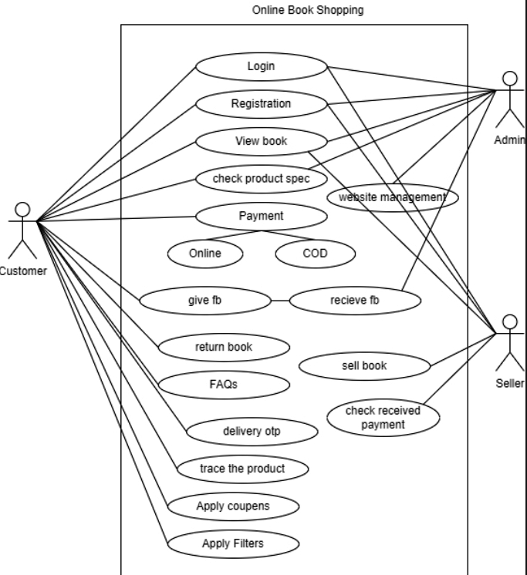

**DRAW USECASE ON ONLINE SHOPPING PRODUCT USING PAYMENT GATWAY**

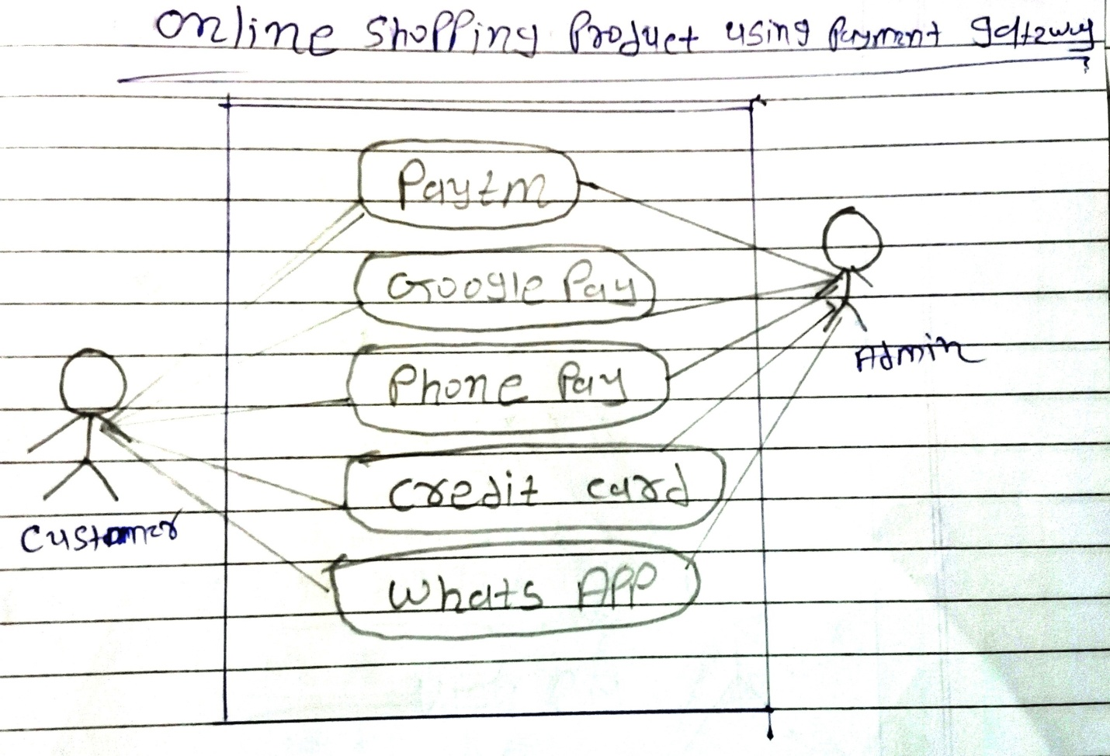

**DRAW USECASE ONLINE SHOPPING PRODUCT USING COD**

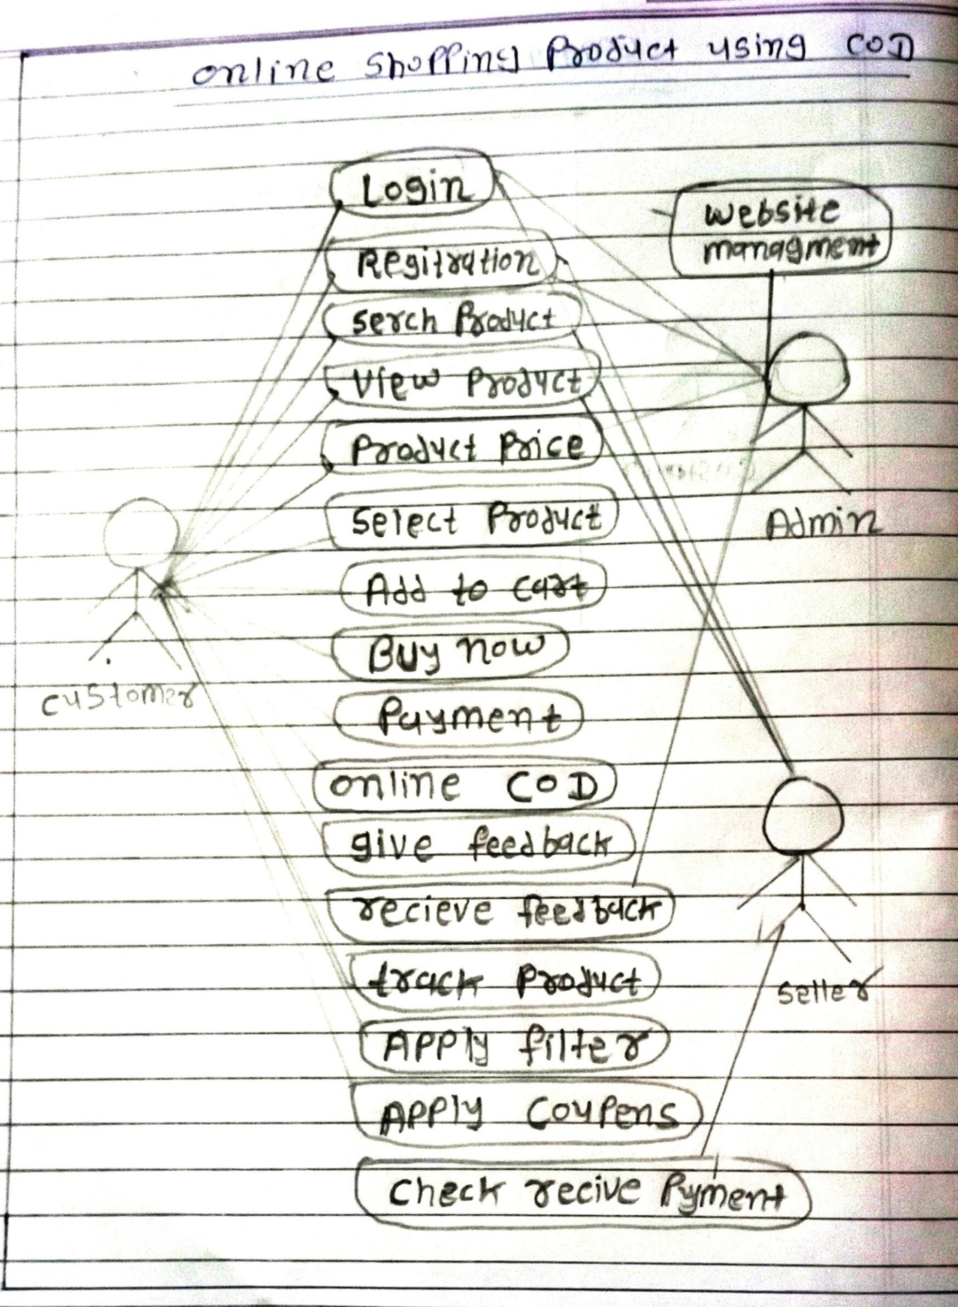

**DRAW USECASE ONLINE BILL PAYMENT SYSTEM (PAYTM)**

